

Feingold syndrome I
Piklova M, Veleminsky M
Hospital Ceske Budejovice, Czechia

Objective
Feingold syndrome I is a rare genetic disorder with autosomal dominant heredity which is caused by heterozygous mutations in MYCN gene on chromosome 2p24. Characteristic clinical findings present at birth are digital anomalies (brachymesophalangy affecting in most cases the 2nd and 5th finger, thumb hypoplasia and toe syndactyly), microcephaly, facial dysmorphism (short palpebral fissures, micrognathia) and gastrointestinal atresias (especially esophageal and duodenal, rarely jejunal or anal). Mild-to-moderate learning disability can become apparent in early childhood.
Methods
A case of neonate born at term with birth weight 3 150g and uncomplicated adaptation after the birth. Examination of newborn revealed anal atresia with perianal fistula, hemodynamically insignificant ventricular septal defect and mild pyelectasis. Brachymesophalangies become evident with growth of the infant.
Results
Molecular genetic testing detected heterozygous deletion on chromosome 2p24.3 where MYCN gene (164840) is located. The same deletion is present at infant´s father (except brachymesophalangies no additional abnormalities are present). Given the fact that each descendant of an individual with Feingold syndrome I has a 50% chance of inheriting this deletion of MYCN gene, genetic counseling is recommended and preimplantation genetic testing is possible.
Conclusion
At present 36 - months old boy is growing well. He underwent successful surgery of anal atresia and ventricular septal defect closed spontaneously. The only clinical features are brachymesophalangies. Boy´s mother is pregnant again, she underwent genetic counseling and refused genetic testing.

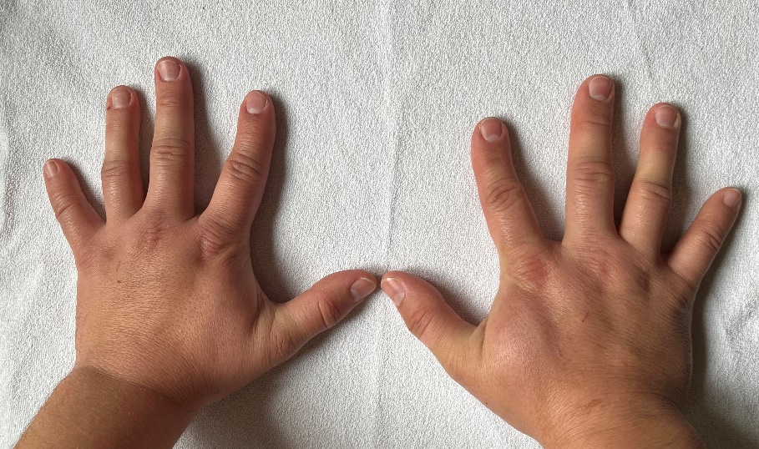
Figure 1. Brachymesophalangy of the 2nd and 5th finger
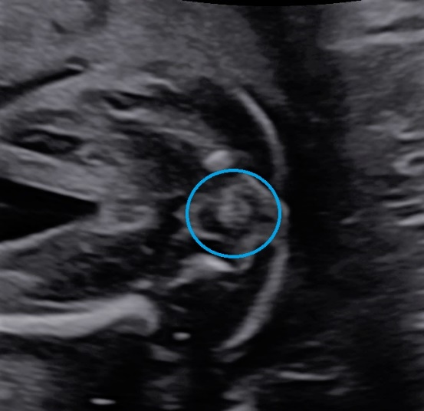
Figure 2. Normal finding: hypoechoic anal sphincter and hyperechoic anal musoca

